Anantha Lakshmi Institute of Technology and Sciences (ALITS)
Department of Data Science

Visualizing Housing Market Trends: An Analysis of Sale Prices and Features using Tableau
Project Demonstration Script

Project Name: Housing Market Trends using Tableau
Team ID: ALITS-DS-2026-HousingMarketTrends
Academic Year: 2026

Project Demonstration
Demo Objective
To showcase the actual Tableau dashboard and storyboard built for the Housing Market Trends project, demonstrating how each element addresses the original problem statement.
Demo Checklist
Item | Status
Transformed Housing Data workbook opens in Tableau Public without errors | Verified
Sheet 1 KPI cards display correct totals | Verified
Sheet 2, 3, 4 render correctly with expected chart types | Verified
Dashboard 1 filters (Age of House) update all sheets | Verified
Story 1 — all 5 story points navigate correctly | Verified

Demonstration Script (Walkthrough)
- Introduce the problem: buyers and analysts lack an interactive way to explore housing price trends.
- Open Dashboard 1 (Comprehensive House Price Analysis) — point out the KPI cards: 21,609 records, 11,055,565,423 total sale price, and 38,643,798 total basement area.
- Walk through Sheet 2 — the Sale Price histogram — highlighting the concentration of sales between 250K–450K.
- Walk through Sheet 3 — the House Age by Renovation Status pie chart — noting the 204 renovated properties reflected in the legend.
- Walk through Sheet 4 — compare bedroom, bathroom, and floor counts across house-age groups.
- Apply the Age of House filter live to demonstrate cross-filtering across all four sheets.
- Navigate through Story 1's five points, reading each caption aloud: Comprehensive House Price → Dashboard Highlights Key → The Sales Distribution → The Age of Houses Varies Based On → House Age Distribution Is.
- Conclude with a summary of insights and future scope.
Storyboard Walkthrough (Actual Screenshots)
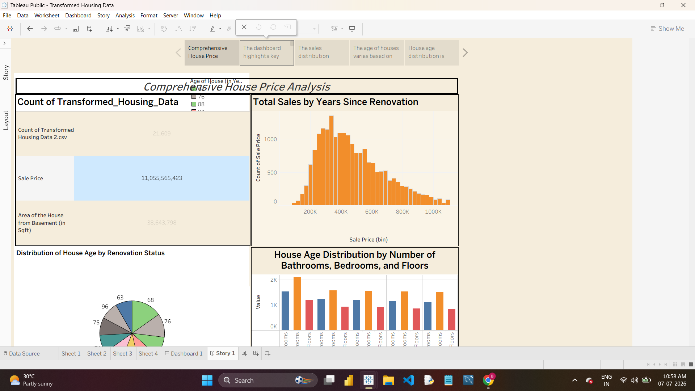
Story 1 — "Comprehensive House Price"
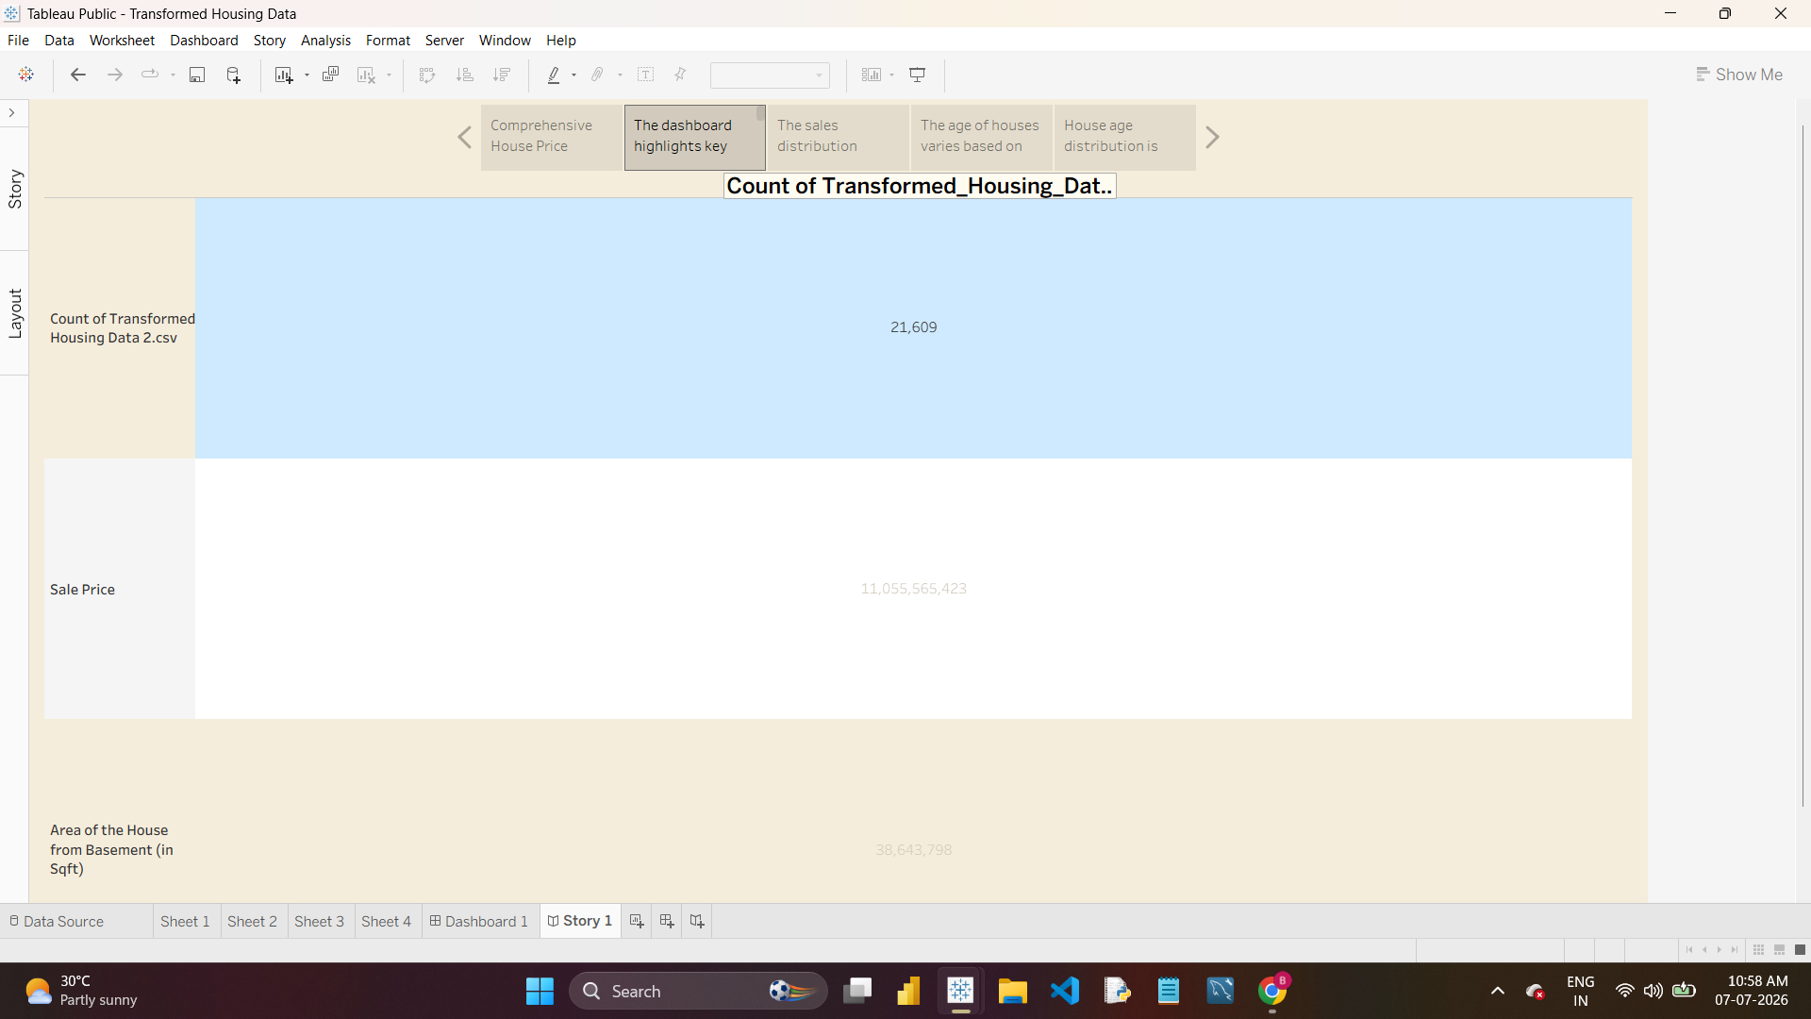
Story 1 — "The dashboard highlights key"
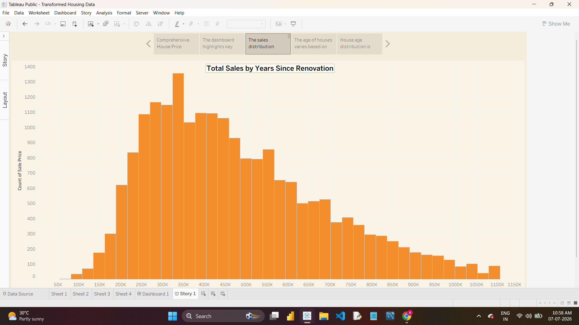
Story 1 — "The sales distribution"
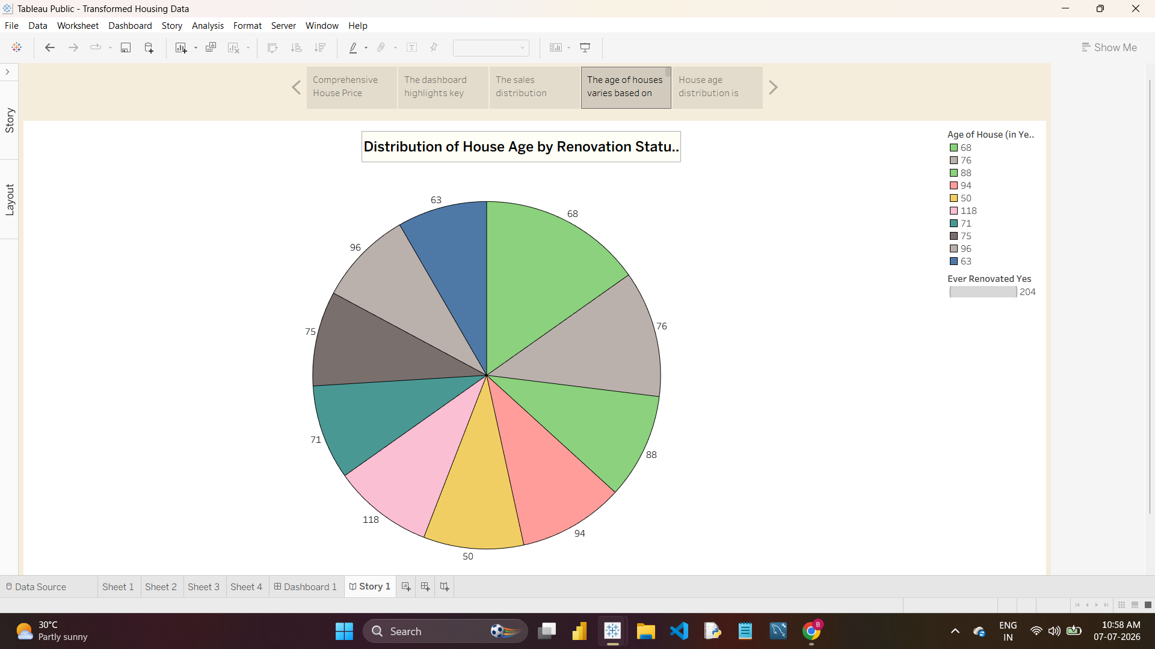
Story 1 — "The age of houses varies based on"
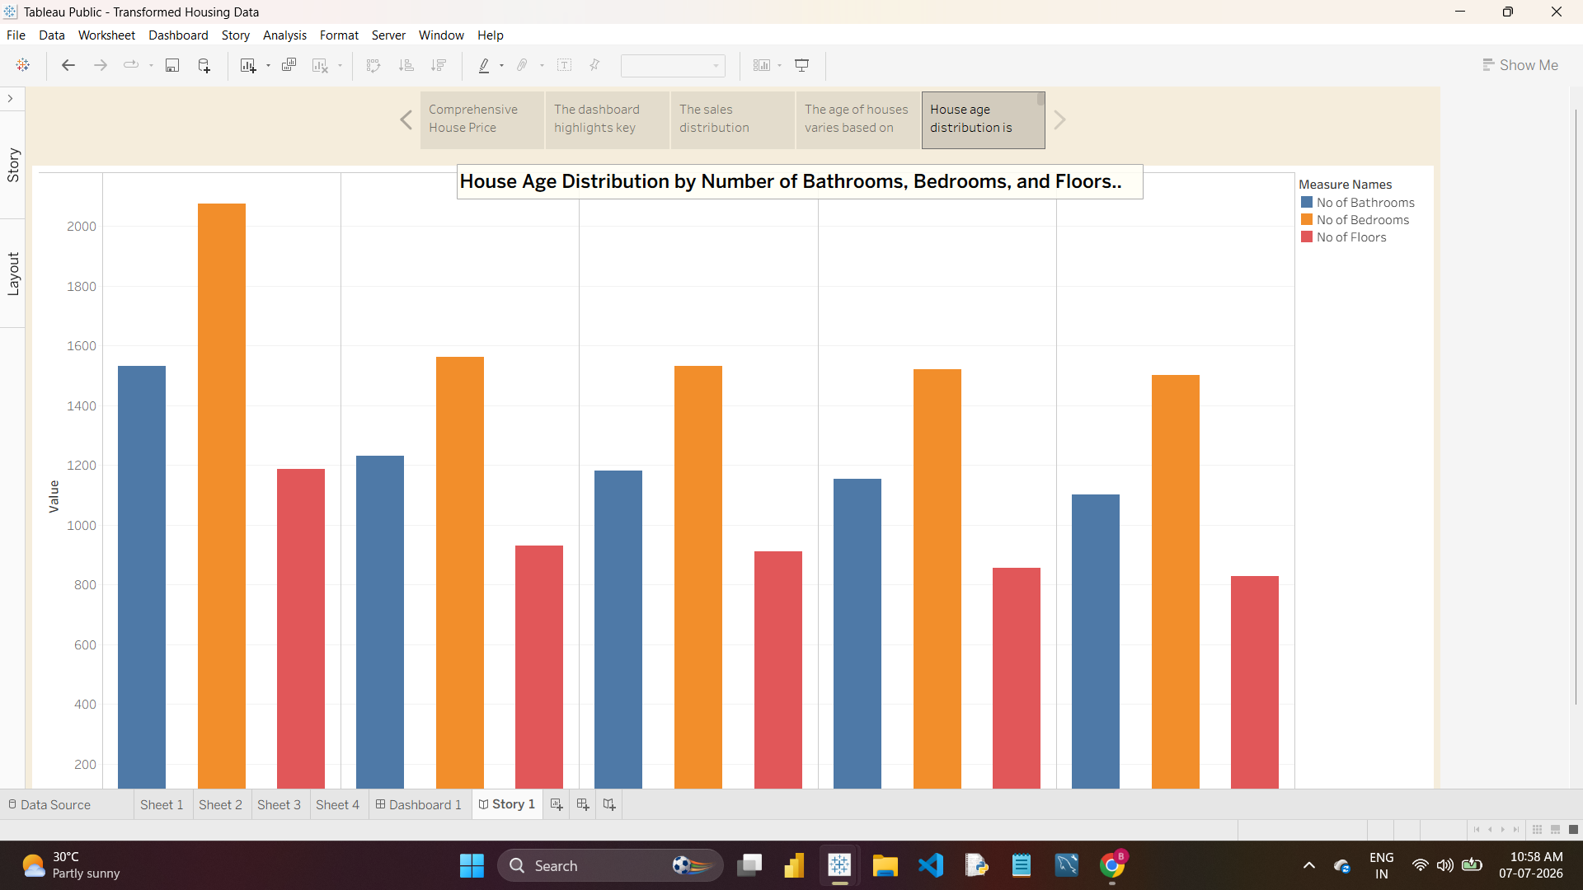
Story 1 — "House age distribution is"
Anticipated Q&A
Question | Response Summary
Why does Sheet 1 show three different totals? | It summarizes Count of records, total Sale Price, and total Area of the House from Basement — three distinct KPIs relevant to market scale.
How was the dataset transformed before loading into Tableau? | Categorical fields such as house condition, renovation status, waterfront view, and zipcode group were one-hot encoded, and numeric fields validated, in Excel prior to import.
Can this scale to a live/larger dataset? | Yes — the same worksheet/dashboard structure can be pointed at a live data connection instead of a static extract.

